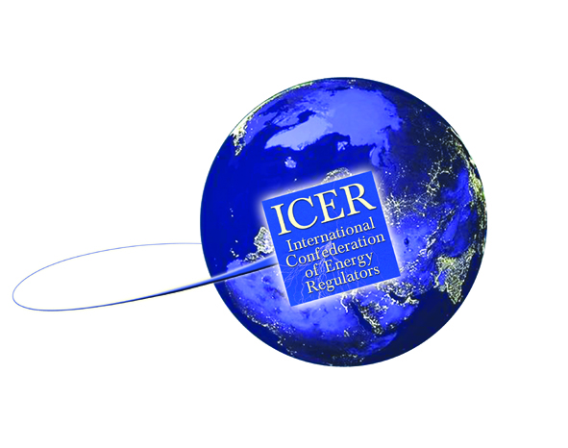

Current Date

US Embassy
Address
City
Country

Dear Sir/Madam,
TO WHOM IT MAY CONCERN

Reference: Applicant name
Passport Number: Applicant passport number
Date of Issue: Passport date of issue
Date of Expiry: Passport date of expiry
Issuing Authority: Passport issuing authority/Place of issue
Date of Birth: Applicant date of birth

The International Confederation of Energy Regulators (ICER) and International Gas Union (IGU) requires Applicant NAME, of Applicant Company/Organisation to travel to Washington D.C, USA to attend the joint ICER-IGU workshop. She/He will be a guest of Dr. Colin Lyle, IGU Strategy Committee Chairman and Harry Whitaker, IGU Strategy Committee Technical Secretary.

The Strategy summit will be held at Hogan Lovells LLP in Washington DC on Tuesday 8th March 2011.

Applicant name will be wholly responsible for all financial payments and expenses. She/He will cover the costs of tickets, transportation and hotel.

For your information, 2 sentence on Applicant Company/Organisation and their objective.

The ICER is a voluntary framework for cooperation between energy regulators from around the world with the objective of improving public and policy maker awareness of energy regulation. The IGU is a worldwide non-profit organisation registered in Vevey, Switzerland, with the present Secretariat located in Oslo, Norway. Its objective is to promote the technical and economic progress of the gas industry.

Should you require any further information, please do not hesitate to contact me.
Harry Whitaker
Technical Secretary
c/o BG Group
Thames Valley Park
Reading Berkshire
RG6 1PT, UK

Tel 0118 929 3107
harry.whitaker@bg-group.com

Yours faithfully,

Harry Whitaker
Technical Secretary
IGU Strategy Committee

