USEFUL MAPS

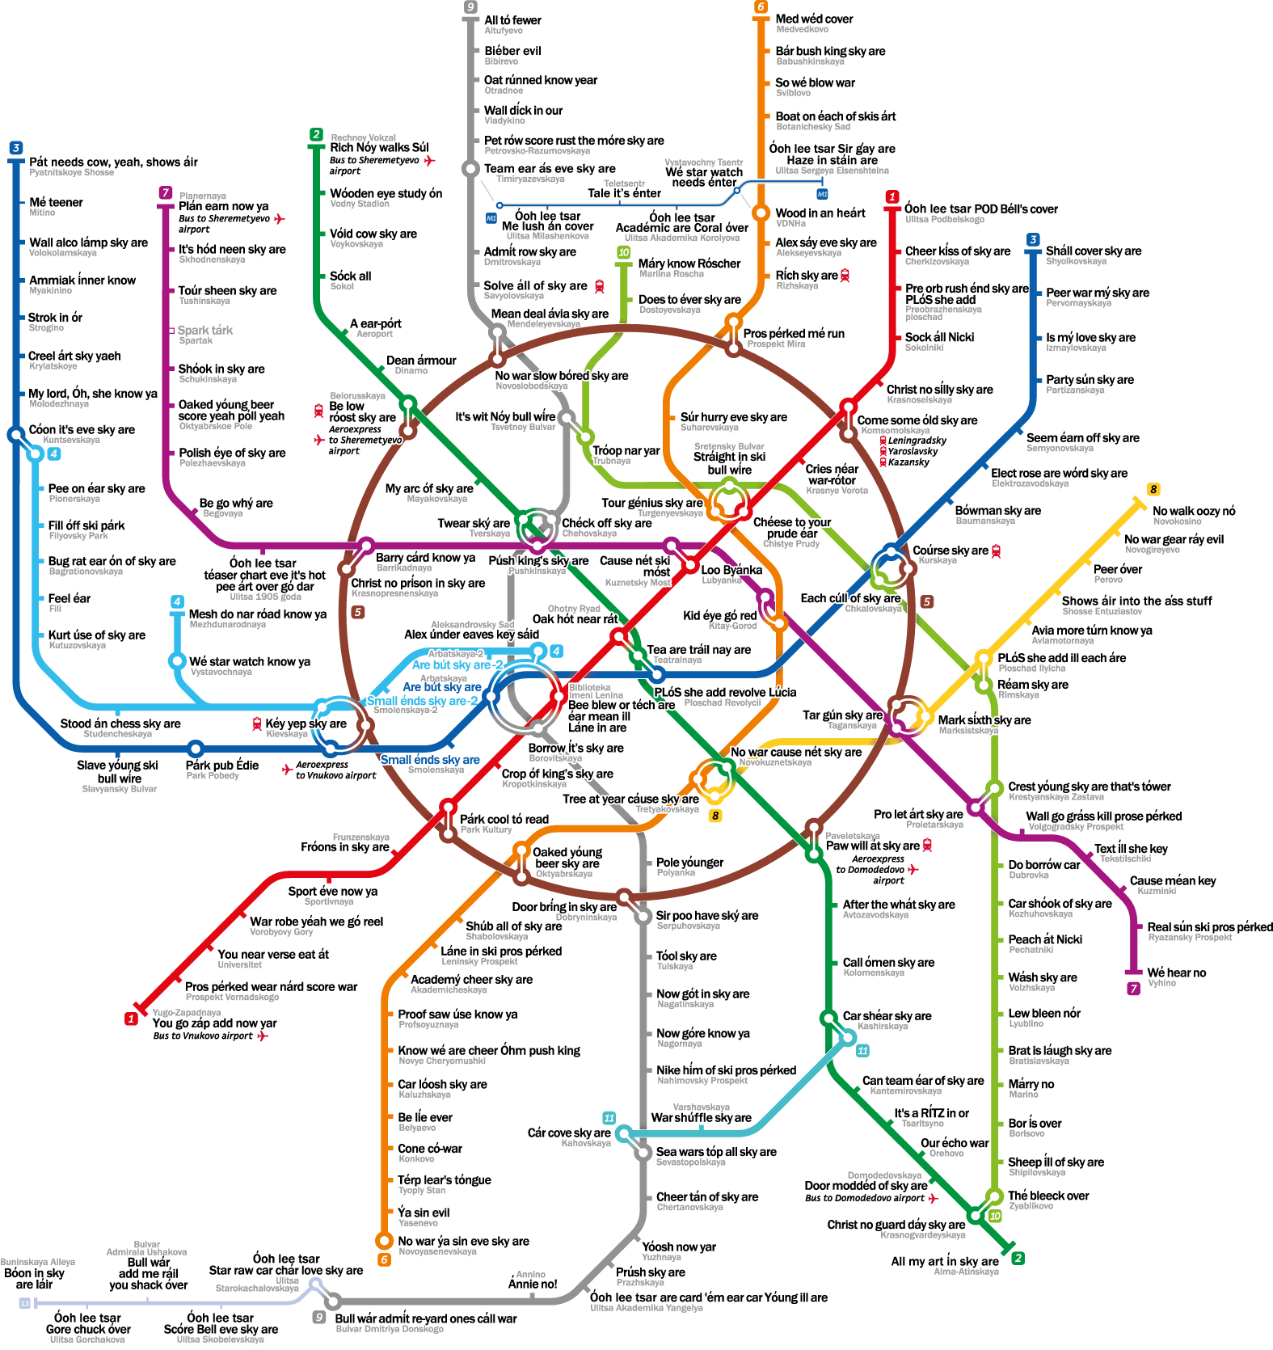
MOSCOW METRO MAP (the stations’ names are written both in Latin and in English words – if you pronounce them)

- MOSCOW AIRPORTS MAP
