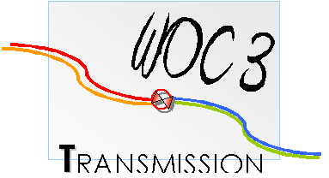
REGISTRATION FORM
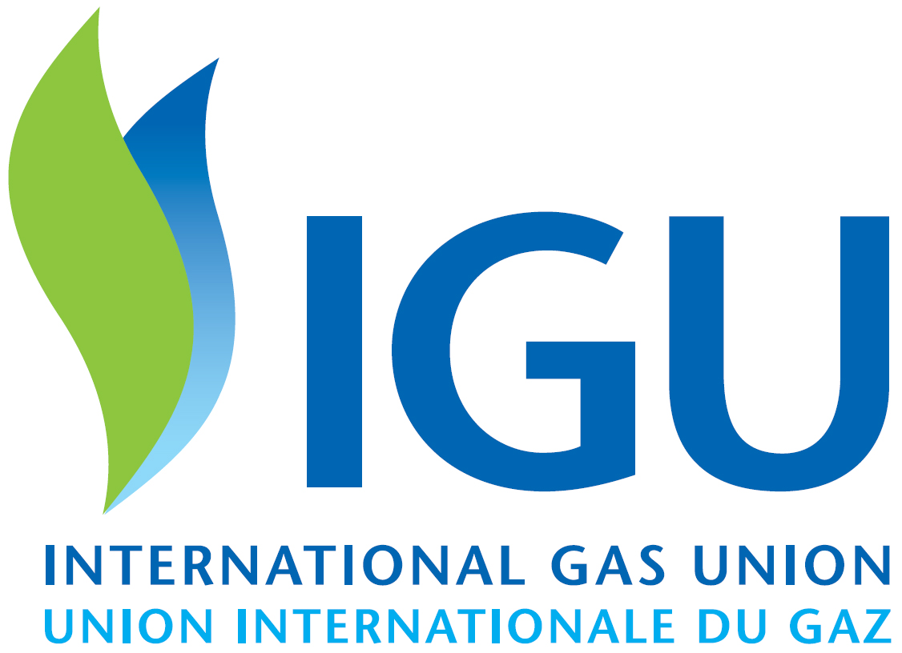
Deadline: August 20th 2014, please return this completed form by email to Milena Jarosova milena.jarosova@cgoa.cz Tel: +420 731 062 074

Name as shown on your passport:
Passport Number: (**)
Company:
Address:
City: |  |  |  |  | State/Province:
Country: |  |  |  |  | Postal Code:
Telephone: |  |  |  |  | email:
Name of Accompanying person as shown on passport:
Passport Number: (**)
Administrative assistant name:
Telephone: |  |  |  |  | Email:
Do you have special food needs (halal, dietary restrictions, etc.?) |  |  | Yes |  | If Yes please specify:
 |  |  | No
Do you need a visa invitation letter? (*) |  |  |  |  | Yes |  |  | If “Yes” you will be contacted by Czech Gas Association immediately
 |  |  |  |  | No
Remarks:
(*) in case visa invitation letter is needed, consular times should be taken into account
(**) compulsory to fill-in only for the technical visit

I will attend:
Welcome Drink on 06/10/2014 | Yes |  |  | No
Meeting on 07/10/2014 | Yes |  |  | No
Dinner on 07/10/2014 | Yes |  |  | No
Meeting on 08/10/2014 | Yes |  |  | No
Dinner on 08/10/2014 | Yes |  |  | No
Technical Visit on 09/10/2014 | Yes |  |  | No

Accompanying person will attend:
Welcome Drink on 06/10/2014 | Yes |  |  | No
Social Programme on 07/10/2014 | Yes |  |  | No
Dinner on 07/10/2014 | Yes |  |  | No
Social Programmme on 08/10/2014 | Yes |  |  | No
Dinner on 08/10/2014 | Yes |  |  | No
Technical Visit on 09/10/2014 | Yes |  |  | No
We will send you confirmation of your registration.

